HITCHAM & TAPLOW SOCIETY

Executive Committee Meeting
Larkspur Mill Lane
Monday 18th September 2023 7.00pm

MINUTES
Present: Apologies:
Eva Lipman (chair) Roger Worthington Robert Hanbury
Jacqueline Turner Cat Howard Charlie Greeves
Rupert Sellers Jonathan Specktor Robert Harrap
Mike Turner Andrew Findlay
Sue Thornton
- MINUTES OF PREVIOUS MEETING
Minutes of the May meeting were agreed and signed.
- MATTERS ARISING
Nothing not covered in the agenda.

- TREASURER’S REPORT
Balances are £9163.25 and £486.24. The VGP made approximately £1,000, of which some £500 was spent for capital items of new equipment. Membership subscriptions are up to date with only one outstanding.
- TECHOLOGY REVIEW
A SumUp device has been acquired and used successfully at the VGP. This supports credit card and contactless payment via a mobile phone.
We have also subscribed to a simple affordable club membership software package, membermojo. It will facilitate online applications and renewals, electronic payment, a central member database and group email distribution. Intended to introduce it over the next couple of months. Mike was congratulated on making such effective progress.

- NEWSLETTER
Roger identified that he was on the short side for content still.
Graham would provide a photo for the committee page. He would also see if he could write something on the creation of the residents company for Mill Lane – check with Berkeley Homes.
Cat would chase a “three ladies” article.
Mike would add the membermojo information to his technology article.
Rupert will write a VGP article and chase the “Gymkana cup” item.
Best to get these done by the end of this week so that the NL can be handed over to Andrew for assembly.
- PLANNING
The long outstanding Huntswood Lane application to demolish an equine centre and convert to residential has been approved on appeal. Larchwood House (Cedar Cottage) and Burwood House are two large properties approved for demolition and complete rebuild.
The Feathers pub has put some of its signage on common land.
There are a number of applications coming in from Cliveden Stud for residential development. One is being taken to the Planning Committee to see if the council has any policy for this important site.
Maryfield earlier had an application refused for a six car garage adjacent to Buffins. They have a new application in for a games room that looks remarkably like a six car garage.
A query to Highways for a date for the Jubilee footbridge restoration produced an answer that it would be this financial year but in rather unconvincing language.
- VGP REPORT
There had been a working debrief soon after the VGP to digest operations. Focus for improvements were:
Getting the fire going hot earlier, Better management of the BBQ fires, Appointing a dedicated fire manager
Separating the veggie/ vegan operation more clearly. Only provide veggie as true vegans likely to distrust the arrangements anyway
Review ticket prices for next year
Health and Safety had improved from last year but needed continuous care.
Rupert was thanked for a very successful event.
- AGM / SPEAKER
Suggestions included someone from Maidenhead talking about changes there or someone from Thames Valley Hospice.
- AOB
Roger apologised for the confusion over the start time. Meetings will be at 7:30 going forwards.
Roger said that he was late on progressing the application for more funding for the Celtic Cross and advised that he wanted to process it via the parish council as they do not pay VAT.
He also said he found he was doing too much and needed to drop one of the things he was doing for the Society. Cat agreed that she would become the editor for the Newsletter, although Roger would continue to provide a significant portion of content.
Next meeting: Monday 16th October 7:30pm Larkspur.

SIGNED:………………………..

Dear Ms. Lipman,
Thank you for your letter.
I have asked the service to provide you with a formal response, which will follow in due course. At this juncture I thought it prudent to answer two salient points in succinct form.
Firstly, the timescale for replacing the bridge section has been changed from the original plan because the Environment Agency refused permission/access for the works as intended due to a conflict with other works that they were undertaking within the area. This was a frustrating development.
Secondly, whilst costs for the replacement have risen – in no small part due to inflationary pressures – capital funds have been specifically allocated to the Berryhill footbridge. This was is the case in the current financial year and, as part of the overall council budget proposals that will be debated (and hopefully approved) on Wednesday this week, these funds remain in the capital programme. This is shown in the screen snippet I have pasted below from the public agenda pack for the full council meeting:
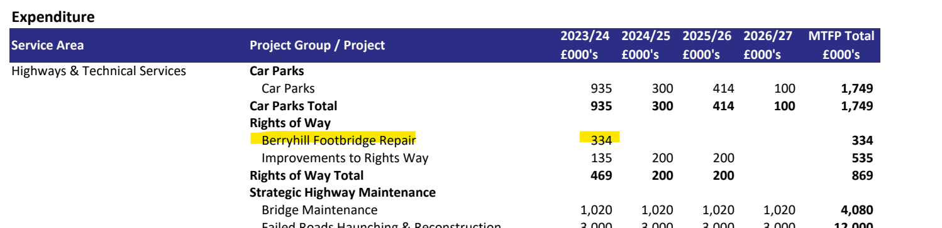

Whilst subject to Environment Agency consent, it is the intention to complete the works in the coming financial year. Naturally I would like to see this important crossing re-opened as soon as possible so the Rights of Way network across the river can be returned to use. I hope these comment reassure you of the plans for this bridge.
Kind regards,
Steven

Steven Broadbent
Cabinet Member for Transport
Councillor for Ridgeway East
Buckinghamshire Council

